**Azure Administrative work:** Green field deployment (scratch nunchi set up cheyadam) or if the internal organization is subscribed to Azure then will give load balancing, additional peering or vpn connectivity or mixture of deployment or troubleshooting or migration activities or pack up activities

**Azure devops:** Deployment work

**Cloud computing:** delivery of computing services small/medium organization will use cloud computing

**Benefits**: Highly scalable (contrast or expand depends on demand). If you’re hosting an IRSCT web site, then spikes will be there between 10 AM to 11 AM then at time if you support infrastructure then web site will run smoothly. After 12 pm to 2pm the services will be moderate and after 2 it will low. Scalability future is In built in Azure. Since it is virtualized environment the VM provisions or remove cheyadam kani fractions of seconds lo jarigipovali. depends on Infrastructure the scaling process should be automatically done.

**Resource Pool**: in global most of the datacenters they have set up the most servers and spreading to worldwide they are so many resources available for utilization. For Microsoft they are so many areas footprint will be available in data centers. Scalability will be built in.

High performance and automatically upgrade to software and always latest hardware

Physical software update automatically not the vm software. Azure usually runs on the physical infrastructure. **Hyper V** infrastructure. Hyper v usually runs on latest software.

**Security:** we are connecting VM with the public. In Security enhancement they are tools available (Security center, AZURE Firewall, ddos protection, azure nsg tool different level lo security will enhancement). Encryption will be default. In Azure 90+ plus products will be available for security.

Around 10 products will be used for infrastructure. Remaining will be the third-party product/vendors like cementic/aspris

Types of Cloud:

**Private Cloud:** Which can be shared internally within the organization

**Public Cloud:** Shared infrastructure. Multiple customers who are subscribed to cloud will get the access to single infrastructure. Security will be built in. underline infrastructure will not be present in your data center and it will be available in Azure data center. In the same infrastructure multiple customers, they will run the infrastructure parallelly.

**Hybrid Cloud:** if you have VM ware setup present and Azure also will be setup and we can connect both using VPN,expressroute VPN or migrate or running the both in parallel.

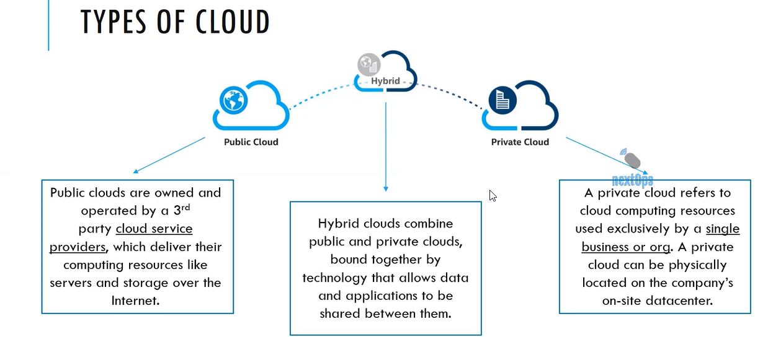

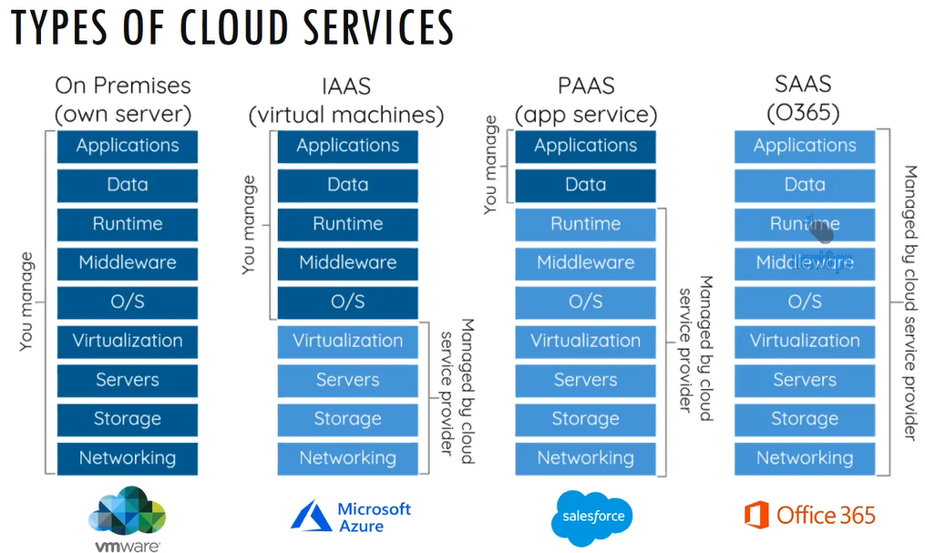

On Premises will be maintained by private cloud. VM Ware Admin will manage vmware and Hyper ware admin will manage hyper. Maintained by network team, storage team, servers team, virtualization team on premises lo unna cloud nu manage chestharu.

IAAS: Infrastructure as a service. If your subscribed to virtual machine, then automatically we are subscribed to IAAS. Level of access/Level of administration manaku cloud provider ku same access. Backend infrastructure for running the VM will manage the cloud service provider like services, stack, storage, virtualization platform. For Azure the virtualization platform default will be hyper v. For running the servers in hyper v they have storage and networking. Aa level of infrastructure ku motham Microsoft will manage

PAAS: Platform as a service. Webapp, Azure SQL, sales force are the examples of PAAS

SAAS: Software as a service. Office 365, Google drive are examples of SAAS.

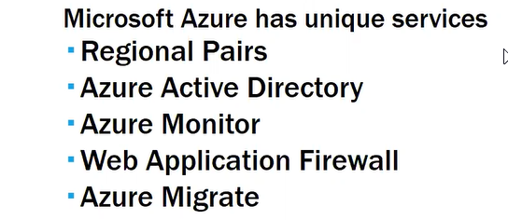

Some of the countries they want to use the Azure and they don’t want to send the data outside of the country. Azure platform will contact third party data center and they will tie up. That platform will provide the datacenter. Local datacenter will be restricted with in the country.

And those are called Feature regions

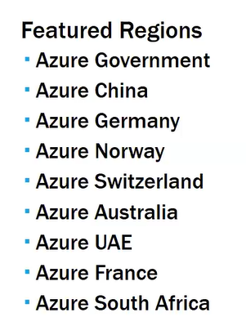

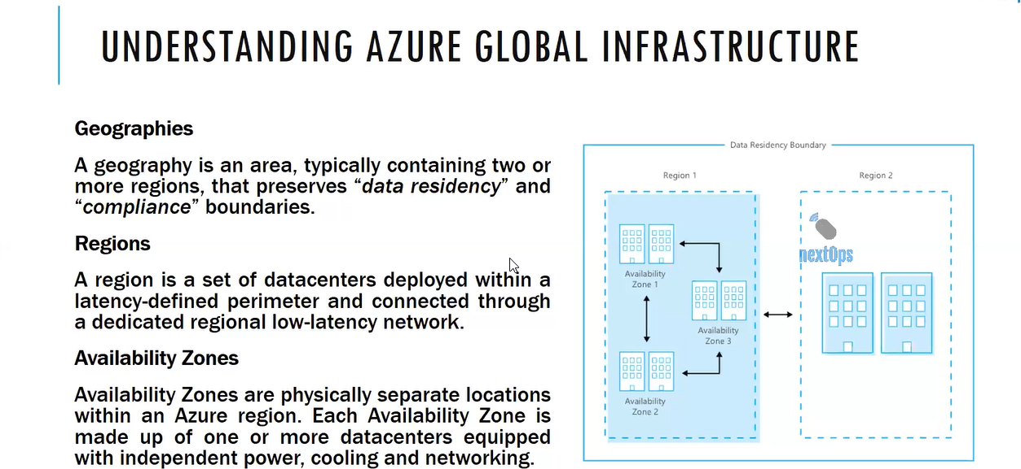

Costumers has to subscribe the and utilize the services so that it will benefit to Azure service.

The services must available to general public services. That is why management portal has been introduced.

For managing the Azure we need Azure portal. “ Portal.Azure.com”

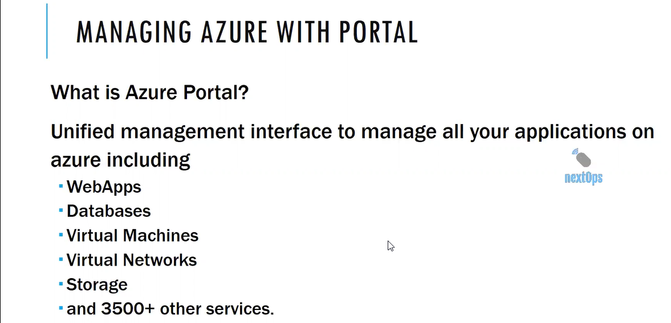

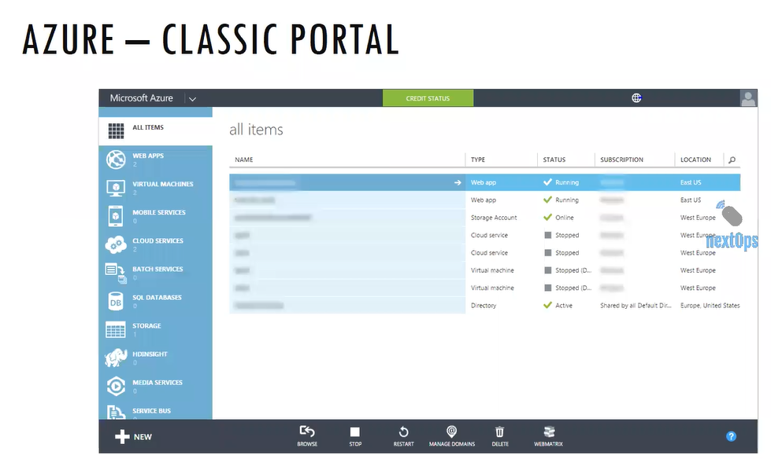

The above one is the old version 1. Manage.azure.windows.com is the url

Azure resources manager brought the portal ARM, and it is enhanced and it is version 2. Portal.azure.com

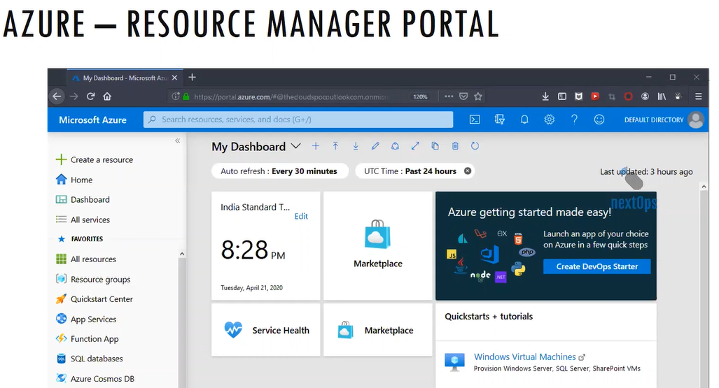

Every service we consume is a resource.

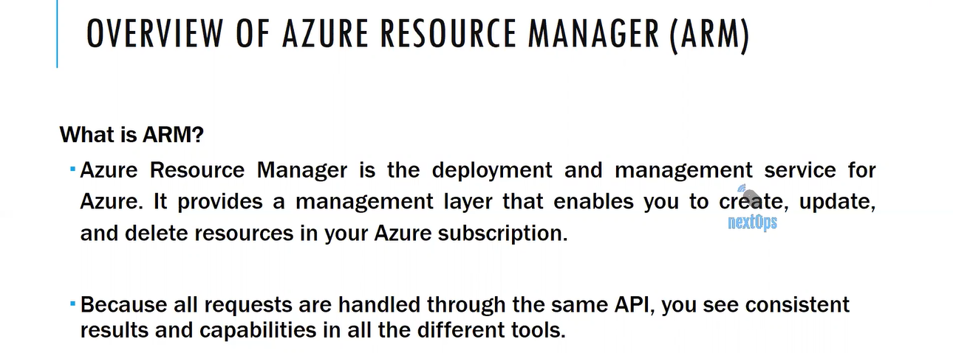

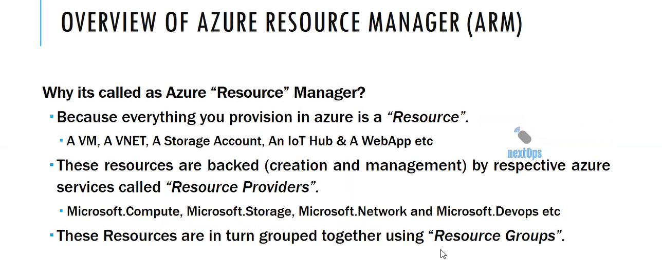

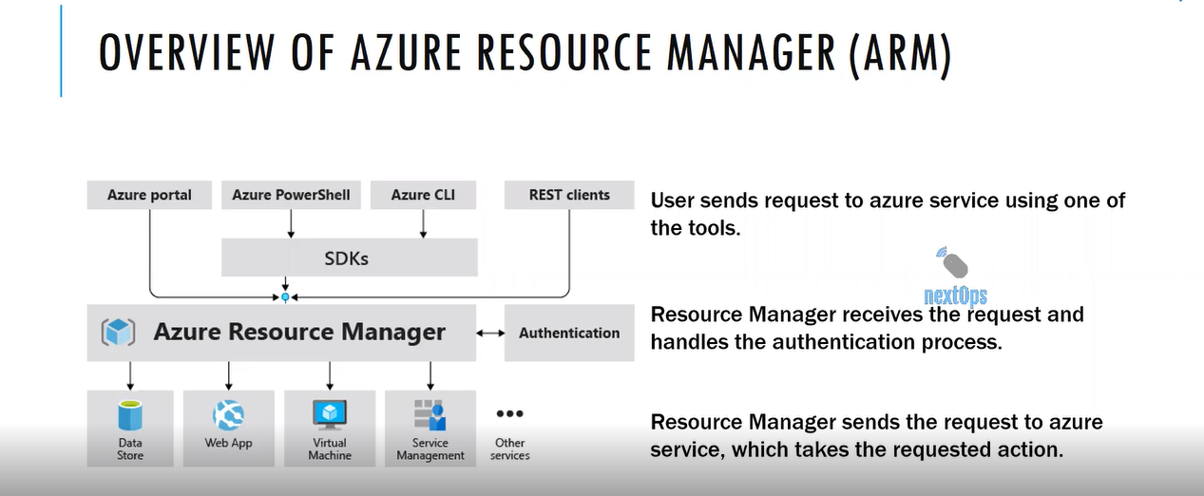

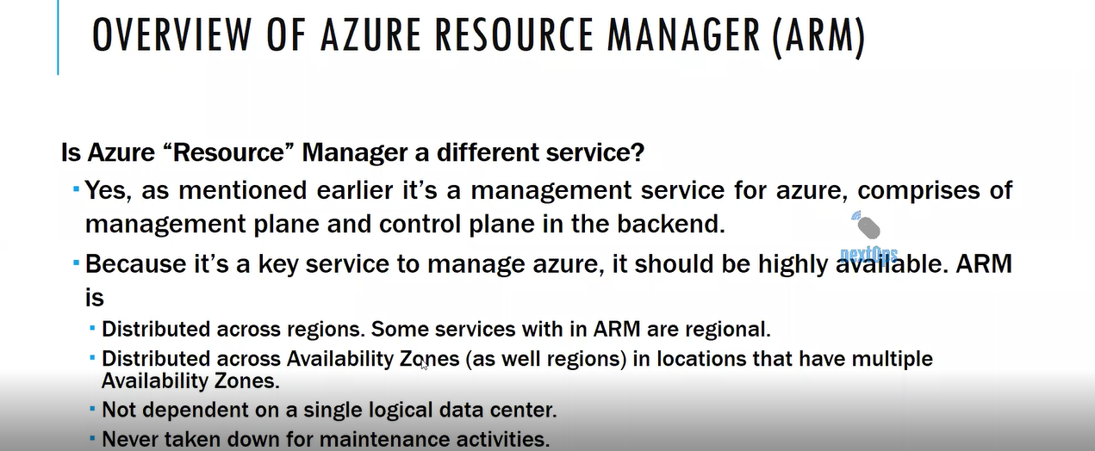In management portal front end is management plane and backend database

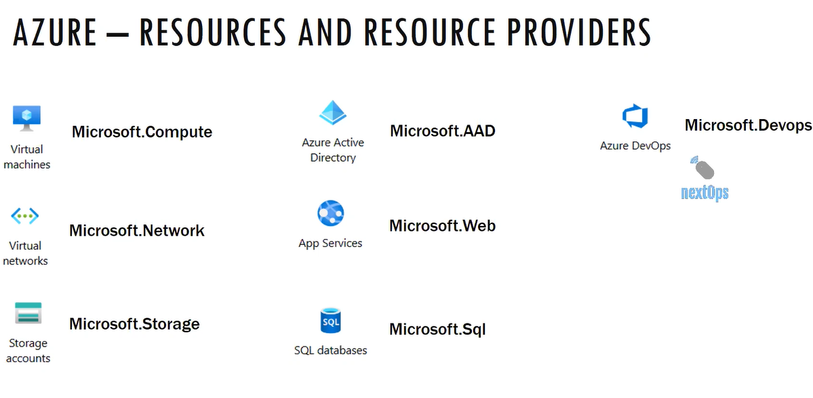

If any one of the resource we are unable to deploy or unable to connect then the resource provide cannot be connect/enabled with the resource

Search the resource explorer there you can see the resource providers which are registered

Go to Resource Provider > if any one of the resource is not registered click on the resource provider you see the status as not registered

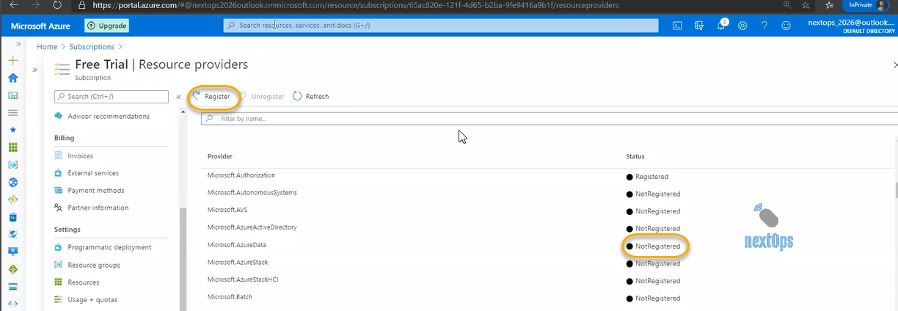

Some of the resources will not be available due to subscriptions, area/region limit then we can contact with Microsoft Azure

In **advisor** overall subscription/recommendation based you can overview that is helpful to our company if any of the resource’s utilization is high

When we create the VM after the life cycle if you delete it in the front end it will be deleted. However, in the backend some of the resources like network interface card, disk and public ip address will be there. So, the in the **advisor** you will see all unwanted resources

If you create the vm machine then public Ip will be linked it and there will no charge if you don’t use the vm then azure will charge the public Ip

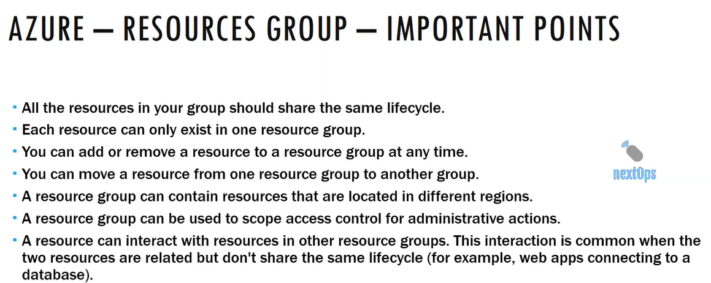

Any update/feature in Microsoft azure version will be first released in EAST US Region

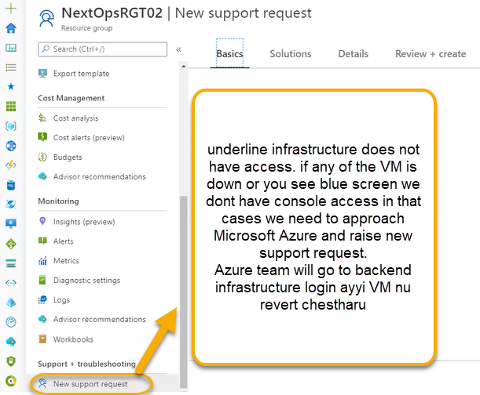

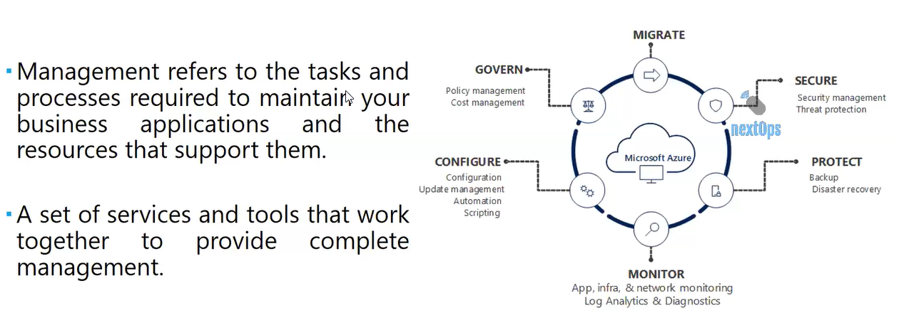

Overview, active log, access control (Identity and Access Management), Tags, Diagnose and solve problem are common labels in Virtual networking, Resource groups. For every 90 days logs will be cleared in Active log

If you want to store the logs or send the logs to another person

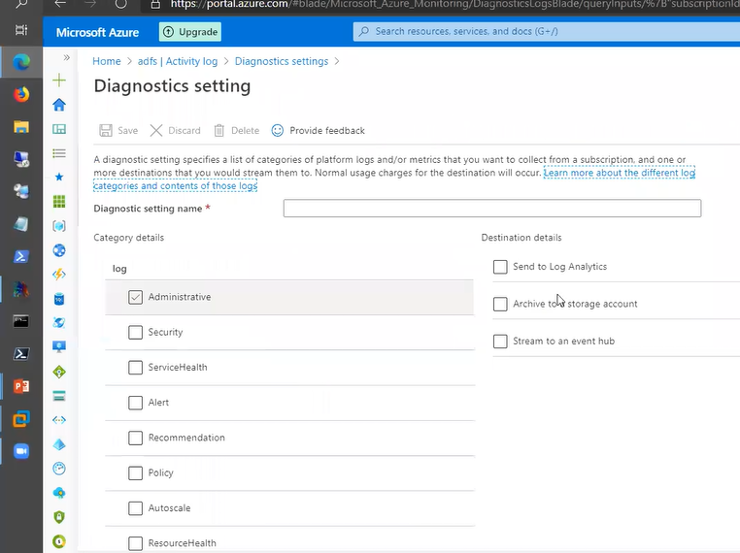

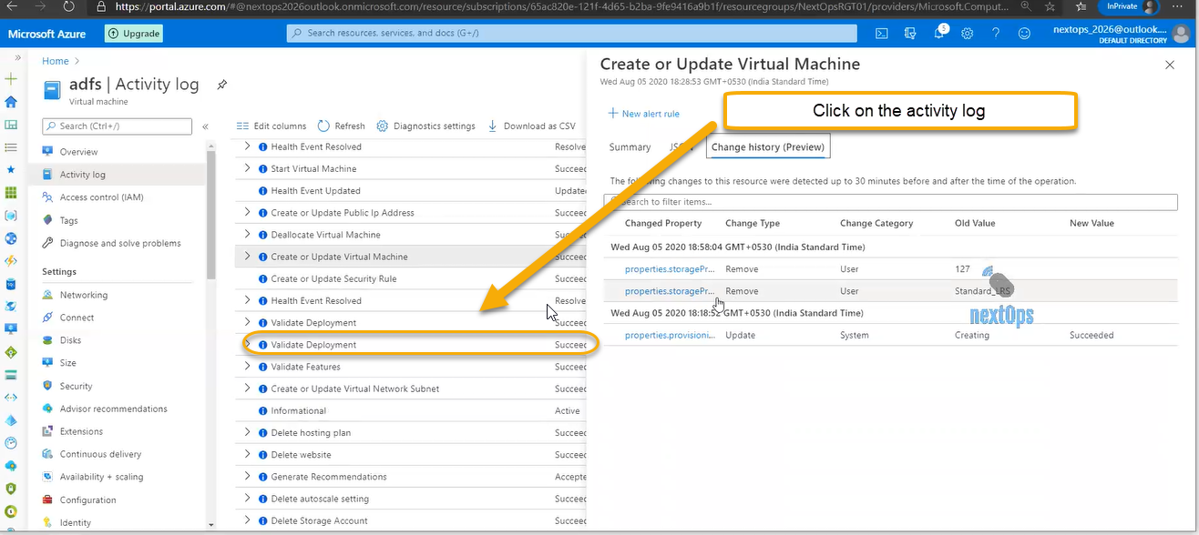

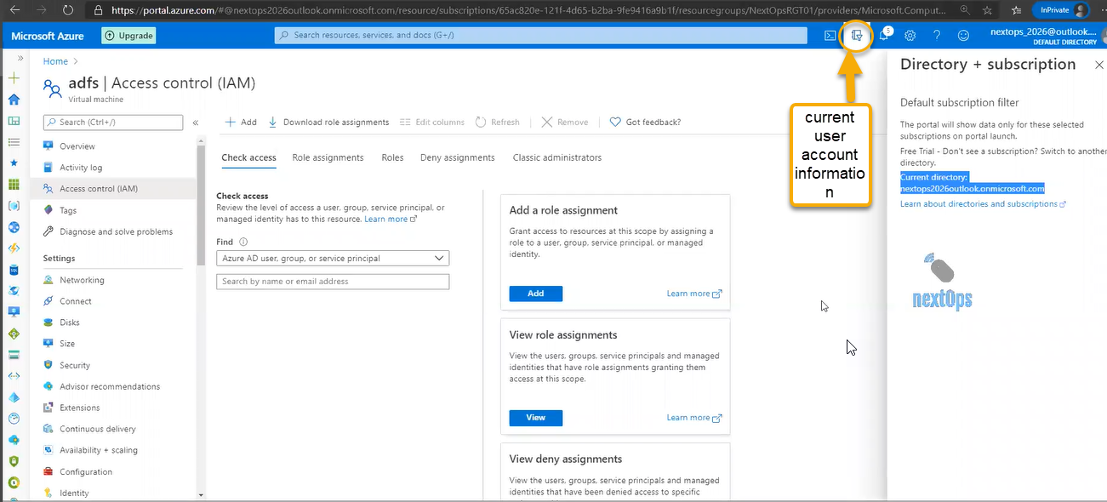

In azure active directory we can create user accounts. Once we create the user we can define access in the control access.

Tag is important when you are filtering the virtual machines you can filter out based on tag. Also for cost analyzing purpose you can use tags

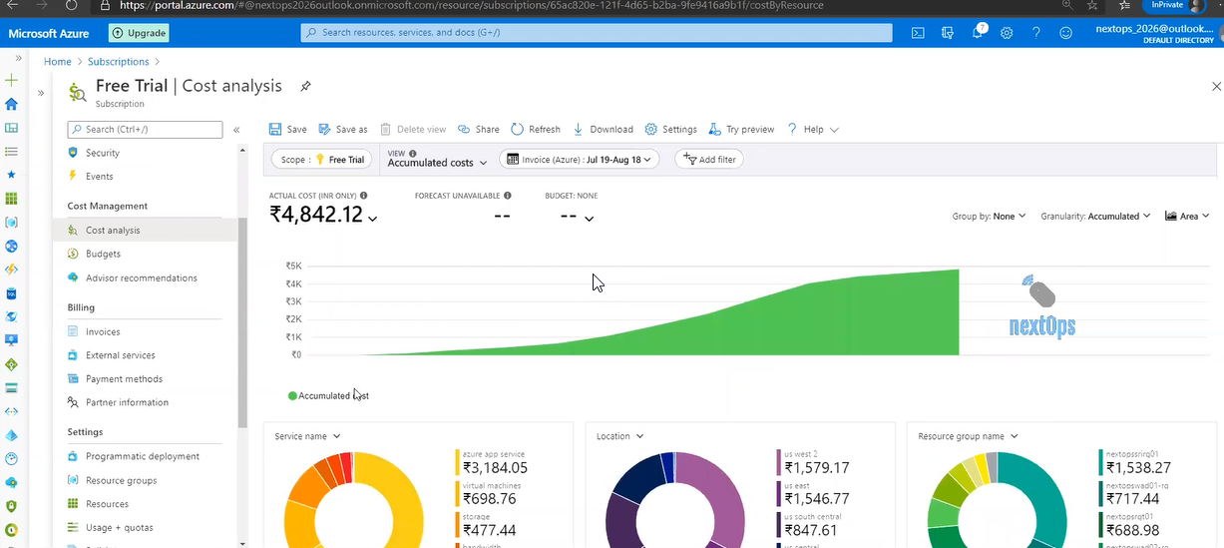

RDP: Remote desktop connection

Active log > Diagnostics setting > + Add diagnostic log